Topic 2: Internetworking Models
Before we move on to Internetworking Models, let’s take a look at a few more network devices that we’ll find in pretty much every network today as shown in Figure 1.6.

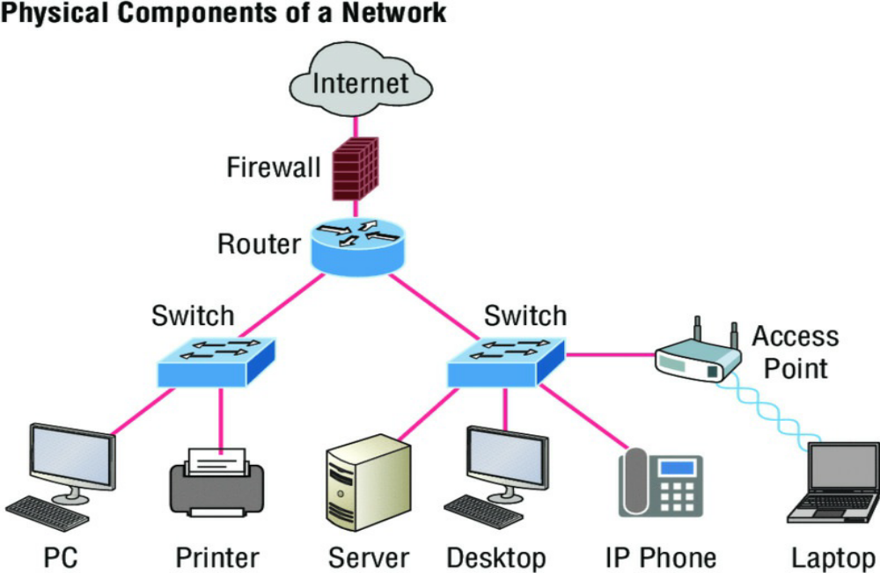
FIGURE 1.6 Other devices typically found in our internetworks today.

Taking off from the switched network in Figure 1.5, you’ll find WLAN devices, including AP’s and wireless controllers, and firewalls. You’d be hard pressed not to find these devices in your networks today.
- WLAN devices: These devices connect wireless devices such as computers, printers, and
tablets to the network. Since pretty much every device manufactured today has a wireless
NIC, you just need to configure a basic access point (AP) to connect to a traditional wired network.
- Access Points or APs: These devices allow wireless devices to connect to a wired network and extend a collision domain from a switch, and are typically in their own broadcast domain or what we’ll refer to as a Virtual LAN (VLAN). An AP can be a simple standalone device, but today they are usually managed by wireless controllers either in house or through the
internet.
- WLAN Controllers: These are the devices that network administrators or network operations centers use to manage access points in medium to large to extremely large quantities. The WLAN controller automatically handles the configuration of wireless access points and was typically used only in larger enterprise systems.
- Firewalls: These devices are network security systems that monitor and control the incoming and outgoing network traffic based on predetermined security rules, and is usually an Intrusion Protection System (IPS).
Internetworking Models
First a little history: When networks first came into being, computers could typically communicate only with computers from the same manufacturer. For example, companies ran either a complete DECnet solution or an IBM solution, never both together. In the late 1970s, the Open Systems Interconnection (OSI) reference model was created by the International Organization for Standardization (ISO) to break through this barrier.

The OSI model was meant to help vendors create interoperable network devices and software in the form of protocols so that different vendor networks could work in peaceable accord with each other. Like world peace, it’ll probably never happen completely, but it’s still a great goal!

Anyway, the OSI model is the primary architectural model for networks. It describes how data and network information are communicated from an application on one computer through the network media to an application on another computer. The OSI reference model breaks this approach into layers.

NOTE: ISO, OSI, and soon you’ll hear about IOS! Just remember that the ISO created the OSI and that Cisco created the Internetworking Operating System (IOS).

The Layered Approach
Understand that a reference model is a conceptual blueprint of how communications should take place. It addresses all the processes required for effective communication and divides them into logical groupings called layers. When a communication system is designed in this manner, it’s known as a hierarchical or layered architecture.

Think of it like this: You and some friends want to start a company. One of the first things you’ll do is sort out every task that must be done and decide who will do what. You would move on to determine the order in which you would like everything to be done with careful consideration of how all your specific operations relate to each other. You would then organize everything into departments (e.g., sales, inventory, and shipping), with each department dealing with its specific responsibilities and keeping its own staff busy enough to focus on their own particular area of the enterprise.

In this scenario, departments are a metaphor for the layers in a communication system. For things to run smoothly, the staff of each department has to trust in and rely heavily upon those in the others to do their jobs well. During planning sessions, you would take notes, recording the entire process to guide later discussions and clarify standards of operation, thereby creating your business blueprint—your own reference model.

And once your business is launched, your department heads, each armed with the part of the blueprint relevant to their own department, will develop practical ways to implement their distinct tasks. These practical methods, or protocols, will then be compiled into a standard operating procedures manual and followed closely because each procedure will have been included for different reasons, delimiting their various degrees of importance and implementation. All of this will become vital if you form a partnership or acquire another company because then it will be really important that the new company’s business model is compatible with yours!

Models happen to be really important to software developers too. They often use a reference model to understand computer communication processes so they can determine which functions should be accomplished on a given layer. This means that if someone is creating a protocol for a certain layer, they only need to be concerned with their target layer’s function. Software that maps to another layer’s protocols and is specifically designed to be deployed there will handle additional functions. The technical term for this idea is binding. The communication processes that are related to each other are bound, or grouped together, at a particular layer.

Advantages of Reference Models
The OSI model is hierarchical, and there are many advantages that can be applied to any layered model, but as I said, the OSI model’s primary purpose is to allow different vendors’ networks to interoperate.

Here’s a list of some of the more important benefits of using the OSI layered model:
- It divides the network communication process into smaller and simpler components, facilitating component development, design, and troubleshooting.
- It allows multiple-vendor development through the standardization of network components.
- It encourages industry standardization by clearly defining what functions occur at each layer of the model.
- It allows various types of network hardware and software to communicate.
- It prevents changes in one layer from affecting other layers to expedite development.

The OSI Reference Model
One of best gifts the OSI specifications gives us is paving the way for the data transfer between disparate hosts running different operating systems, like Unix hosts, Windows machines, Macs, smartphones, and so on.

And remember, the OSI is a logical model, not a physical one. It’s essentially a set of guidelines that developers can use to create and implement applications to run on a network. It also provides a framework for creating and implementing networking standards, devices, and internetworking schemes.

The OSI has seven different layers, divided into two groups. The top three layers define how the applications within the end stations will communicate with each other as well as with users. The bottom four layers define how data is transmitted end to end.

Figure 1.7 shows the three upper layers and their functions.
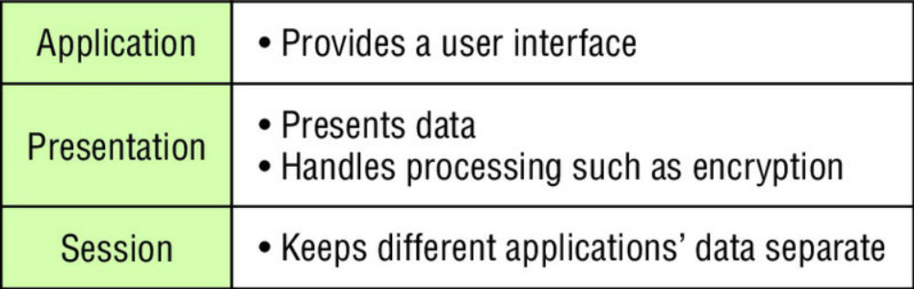2
FIGURE 1.7 The upper layers

When looking at Figure 1.6, understand that users interact with the computer at the Application layer and also that the upper layers are responsible for applications communicating between hosts. None of the upper layers knows anything about networking or network addresses because that’s the responsibility of the four bottom layers.

In Figure 1.8, which shows the four lower layers and their functions, you can see that it’s these four bottom layers that define how data is transferred through physical media like wire, cable, fiber optics, switches, and routers. These bottom layers also determine how to rebuild a data stream from a transmitting host to a destination host’s application.

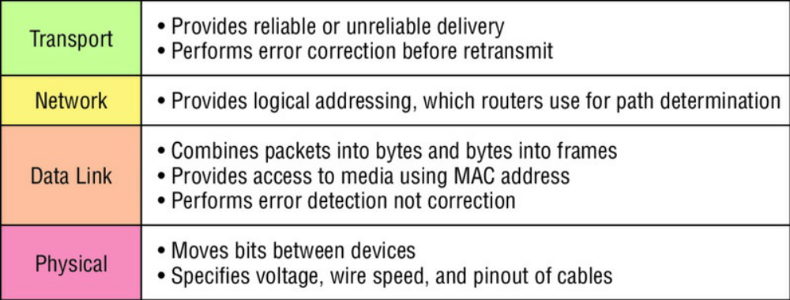
FIGURE 1.8 The lower layers

The following network devices operate at all seven layers of the OSI model:
- Network management stations (NMSs)
- Web and application servers
- Gateways (not default gateways)
- Servers
- Network hosts

The ISO developed the OSI reference model act as the precedent and guide for an open network protocol set. It defines the etiquette of communication models, it remains the most popular means of
comparison for protocol suites today.

The OSI reference model has the following seven layers:
- Application layer (layer 7)
- Presentation layer (layer 6)
- Session layer (layer 5)
- Transport layer (layer 4)
- Network layer (layer 3)
- Data Link layer (layer 2)
- Physical layer (layer 1)

Some people like to use a mnemonic to remember the seven layers, such as All People Seem To Need Data Processing. Figure 1.9 shows a summary of the functions defined at each layer of the OSI model.

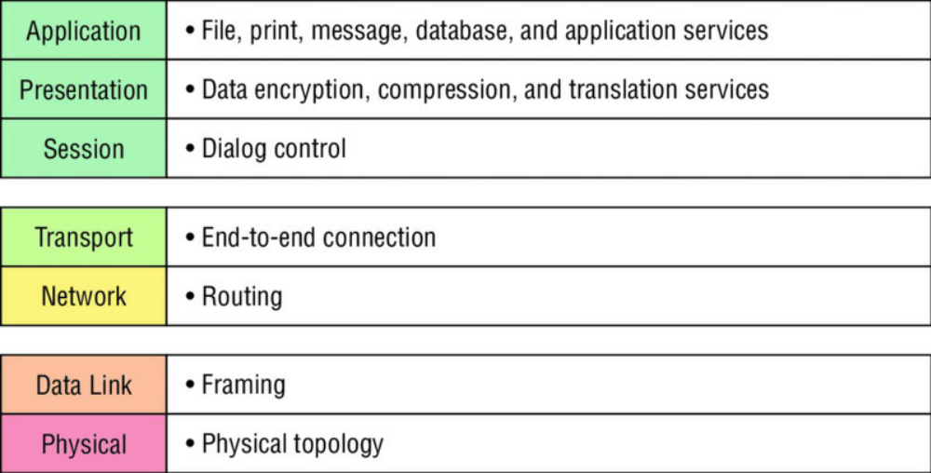
FIGURE 1.9 OSI layer functions

I’ve separated the seven-layer model into three different functions: the upper layers, the middle layers, and the bottom layers. The upper layers communicate with the user interface and application, the middle layers do reliable communication and routing to a remote network, and the bottom layers communicate to the local network. With this in hand, you’re now ready to explore each layer’s function in detail!

The Application Layer
The Application layer of the OSI model marks the spot where users actually communicate to the computer and comes into play only when it’s clear that access to the network will be needed soon. Take the case of Internet Explorer (IE). You could actually uninstall every trace of networking components like TCP/IP, the NIC card, and so on and still use IE to view a local HTML document. But things would get ugly if you tried to do things like view a remote HTML document that must be retrieved because IE and other browsers act on these types of requests by attempting to access the Application layer. So basically, the Application layer is working as the interface between the actual application program and the next layer down by providing ways for the application to send information down through the protocol stack. This isn’t actually part of the layered structure, because browsers don’t live in the Application layer, but they interface with it as well as the relevant protocols when asked to access remote resources.

Identifying and confirming the communication partner’s availability and verifying the required resources to permit the specified type of communication to take place also occurs at the Application layer. This is important because, like the lion’s share of browser functions, computer applications sometimes need more than desktop resources. It’s more typical than you would think for the communicating components of several network applications to come together to carry out a requested function. Here are a few good examples of these kinds of events:
- File transfers
- Email
- Enabling remote access
- Network management activities
- Client/server processes
- Information location

The Application layer works as the interface between actual application programs. This means end-user programs like Microsoft Word don’t reside at the Application layer, they interface with the Application layer protocols.

The Presentation Layer
The Presentation layer gets its name from its purpose: It presents data to the Application layer and is responsible for data translation and code formatting. Think of it as the OSI model’s translator, providing coding and conversion services. One very effective way of ensuring a successful data transfer is to convert the data into a standard format before transmission. Computers are configured to receive this generically formatted data and then reformat it back into its native state to read it. An example of this type of translation service occurs when translating old Extended Binary Coded Decimal Interchange Code (EBCDIC) data to ASCII, ther American Standard Code for Information Interchange (often pronounced “askee”). So just remember that by providing translation services, the Presentation layer ensures that data transferred from the Application layer of one system can be read by the Application layer of another one.

With this in mind, it follows that the OSI would include protocols that define how standard data should be formatted, so key functions like data compression, decompression, encryption, and decryption are also associated with this layer. Some Presentation layer standards are involved in multimedia operations as well.

The Session Layer
The Session layer is responsible for setting up, managing, and dismantling sessions between Presentation layer entities and keeping user data separate. Dialog control between devices also occurs at this layer.

Communication between hosts’ various applications at the Session layer, as from a client to a server, is coordinated and organized via three different modes: simplex, half-duplex, and fullduplex. Simplex is simple one-way communication, kind of like saying something and not getting a reply. Half-duplex is actual two-way communication, but it can take place in only one direction at a time, preventing the interruption of the transmitting device. It’s like when pilots and ship captains communicate over their radios, or even a walkie-talkie. But full-duplex is exactly like a real conversation where devices can transmit and receive at the same time, much like two people arguing or interrupting each other during a telephone conversation.

The Transport Layer
The Transport layer segments and reassembles data into a single data stream. Services located at this layer take all the various data received from upper-layer applications, then combine it into the same, concise data stream. These protocols provide end-to-end data transport services and can establish a logical connection between the sending host and destination host on an internetwork.

A pair of well-known protocols called TCP and UDP are integral to this layer. We will discuss this in chapter 3. For now, understand that although both work at the Transport layer, TCP is known as a reliable service but UDP is not. This distinction gives application developers more options because they have a choice between the two protocols when they are designing products for this layer. The Transport layer is responsible for providing mechanisms for multiplexing upper-layer applications, establishing sessions, and tearing down virtual circuits. It can also hide the details of network-dependent information from the higher layers as well as provide transparent data transfer.
NOTE: The term reliable networking can be used at the Transport layer. Reliable networking requires that acknowledgments, sequencing, and flow control will all be used.

The Transport layer can be either connectionless or connection-oriented

Connection-Oriented Communication
For reliable transport to occur, a device that wants to transmit must first establish a connection-oriented communication session with a remote device—its peer system—known as a call setup or
a three-way handshake. Once this process is complete, the data transfer occurs, and when it’s finished, a call termination takes place to tear down the virtual circuit.

Figure 1.10 depicts a typical reliable session taking place between sending and receiving systems. In it, you can see that both hosts’ application programs begin by notifying their individual operating systems that a connection is about to be initiated. The two operating systems communicate by sending messages over the network confirming that the transfer is approved and that both sides are ready for it to take place. After all of this required synchronization takes place, a connection is fully established and the data transfer begins. And by the way, it’s really helpful to understand that this virtual circuit setup is often referred to as overhead!

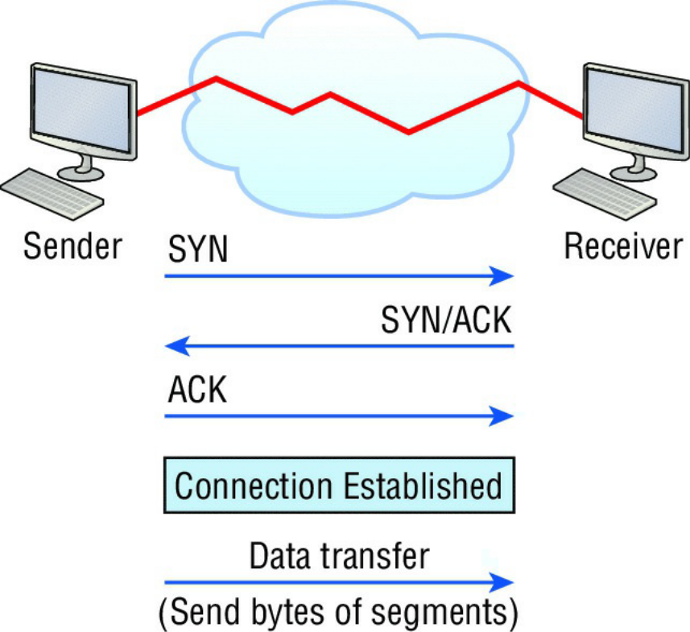

FIGURE 1.10 Establishing a connection-oriented session

Okay, now while the information is being transferred between hosts, the two machines periodically check in with each other, communicating through their protocol software to ensure that all is going well and that the data is being received properly.

Here’s a summary of the steps in the connection-oriented session—that three-way handshake—pictured in Figure 1.9:
- The first “connection agreement” segment is a request for synchronization (SYN).
- The next segments acknowledge (ACK) the request and establish connection parameters—the rules—between hosts. These segments request that the receiver’s sequencing is synchronized here as well so that a bidirectional connection can be formed.
- The final segment is also an acknowledgment, which notifies the destination host that the connection agreement has been accepted and that the actual connection has been established. Data transfer can now begin.

Sometimes during a transfer, congestion can occur because a high-speed computer is generating data traffic a lot faster than the network itself can process it! And a whole bunch of computers simultaneously sending datagrams through a single gateway or destination can also jam things up pretty badly. In the latter case, a gateway or destination can become congested even though no single source caused the problem. Either way, the problem is basically akin to a freeway bottleneck—too much traffic for too small a capacity. It’s not usually one car that’s the problem; it’s just that there are way too many cars on that freeway at once!

But what actually happens when a machine receives a flood of datagrams too quickly for it to process? It stores them in a memory section called a buffer. Sounds great; it’s just that this buffering action can solve the problem only if the datagrams are part of a small burst. If the datagram deluge continues, eventually exhausting the device’s memory, its flood capacity will be exceeded and it will dump any and all additional datagrams it receives just like an inundated overflowing bucket! Therefore, we need flow control.

Flow Control
Since floods and losing data can both be tragic, we have a fail-safe solution in place known as flow control. Its job is to ensure data integrity at the Transport layer by allowing applications to request reliable data transport between systems. Flow control prevents a sending host on one side of the connection from overflowing the buffers in the receiving host. Reliable data transport employs a connection-oriented communications session between systems, and the protocols involved ensure that the following will be achieved:
- The segments delivered are acknowledged back to the sender upon their reception.
- Any segments not acknowledged are retransmitted.
- Segments are sequenced back into their proper order upon arrival at their destination.
- A manageable data flow is maintained in order to avoid congestion, overloading, or worse, data loss.
NB: The purpose of flow control is to provide a way for the receiving device to control the amount of data sent by the sender.

Because of the transport function, network flood control systems really work well. Instead of dumping and losing data, the Transport layer can issue a “not ready” indicator to the sender, or potential source of the flood. This mechanism works kind of like a stoplight, signaling the sending
device to stop transmitting segment traffic to its overwhelmed peer. After the peer receiver processes the segments already in its memory reservoir—its buffer—it sends out a “ready” transport indicator. When the machine waiting to transmit the rest of its datagrams receives this “go” indicator, it resumes its transmission. The process is pictured in Figure 1.11.
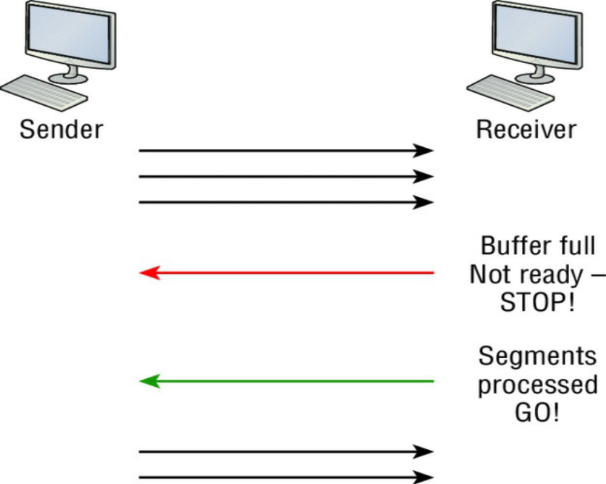
FIGURE 1.11 Transmitting segments with flow control

In a reliable, connection-oriented data transfer, datagrams are delivered to the receiving host hopefully in the same sequence they’re transmitted. A failure will occur if any data segments are lost, duplicated, or damaged along the way—a problem solved by having the receiving host acknowledge that it has received each and every data segment.

A service is considered connection-oriented if it has the following characteristics:
- A virtual circuit, or “three-way handshake,” is set up.
- It uses sequencing.
- It uses acknowledgments.
- It uses flow control.

NB: The types of flow control are buffering, windowing, and congestion avoidance.

Windowing
Ideally, data throughput happens quickly and efficiently. And as you can imagine, it would be painfully slow if the transmitting machine had to actually wait for an acknowledgment after sending each and every segment! The quantity of data segments, measured in bytes, that the transmitting machine is allowed to send without receiving an acknowledgment is called a window.
NB: Windows are used to control the amount of outstanding, unacknowledged data segments.

The size of the window controls how much information is transferred from one end to the other before an acknowledgement is required. While some protocols quantify information depending on the number of packets, TCP/IP measures it by counting the number of bytes.

As you can see in Figure 1.12, there are two window sizes—one set to 1 and one set to 3.
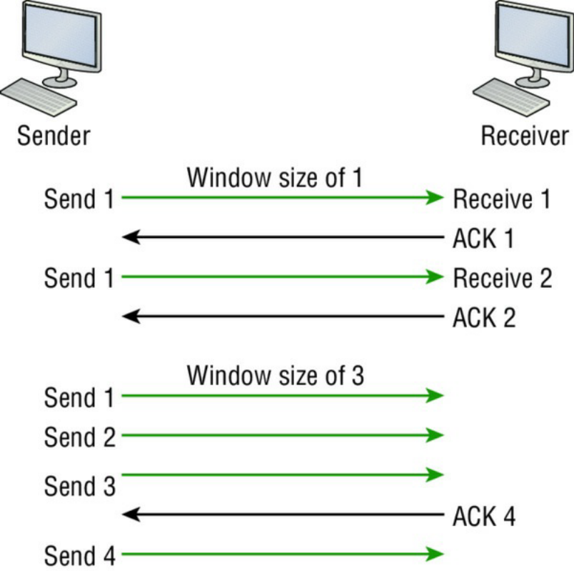
FIGURE 1.12 Windowing

If you’ve configured a window size of 1, the sending machine will wait for an acknowledgment for each data segment it transmits before transmitting another one but will allow three to be transmitted before receiving an acknowledgement if the window size is set to 3.

In this simplified example, both the sending and receiving machines are workstations. Remember
that in reality, the transmission isn’t based on simple numbers but in the amount of bytes that can
be sent!
NOTE: If a receiving host fails to receive all the bytes that it should acknowledge, the host can improve the communication session by decreasing the window size.

Acknowledgments
Reliable data delivery ensures the integrity of a stream of data sent from one machine to the other through a fully functional data link. It guarantees that the data won’t be duplicated or lost. This is achieved through something called positive acknowledgment with retransmission—a technique that requires a receiving machine to communicate with the transmitting source by sending an acknowledgment message back to the sender when it receives data. The sender documents each segment measured in bytes, then sends and waits for this acknowledgment before sending the next segment. Also important is that when it sends a segment, the transmitting machine starts a timer and will retransmit if it expires before it gets an acknowledgment back from the receiving end. Figure 1.13 shows the process I just described.

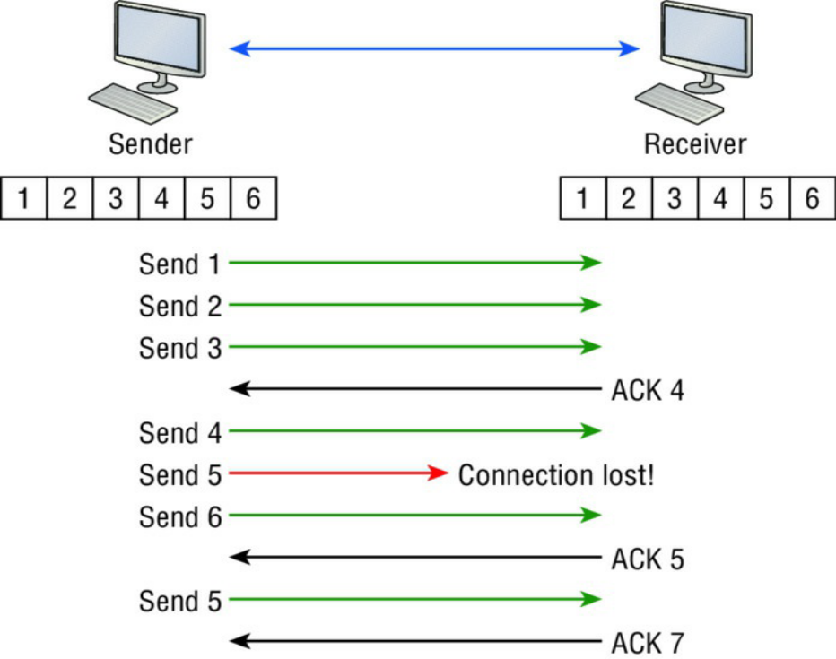
FIGURE 1.13 Transport layer reliable delivery

In the figure, the sending machine transmits segments 1, 2, and 3. The receiving node acknowledges that it has received them by requesting segment 4 (what it is expecting next). When it receives the acknowledgment, the sender then transmits segments 4, 5, and 6. If segment 5 doesn’t make it to the destination, the receiving node acknowledges that event with a request for the segment to be re-sent. The sending machine will then resend the lost segment and wait for an acknowledgment, which it must receive in order to move on to the transmission of segment 7.

The Transport layer, working in tandem with the Session layer, also separates the data from different applications, an activity known as session multiplexing, and it happens when a client connects to a server with multiple browser sessions open. This is exactly what’s taking place when you go someplace online like Amazon and click multiple links, opening them simultaneously to get information when comparison shopping. The client data from each browser session must be separate when the server application receives it, which is pretty slick technologically speaking, and it’s the Transport layer to the rescue for that juggling act!

The Network Layer
The Network layer, or layer 3, manages device addressing, tracks the location of devices on the network, and determines the best way to move data. This means that it’s up to the Network layer to transport traffic between devices that aren’t locally attached. Routers, which are layer 3 devices, are specified at this layer and provide the routing services within an internetwork.

Here’s how that works: first, when a packet is received on a router interface, the destination IP address is checked. If the packet isn’t destined for that particular router, it will look up the destination network address in the routing table. Once the router chooses an exit interface, the packet will be sent to that interface to be framed and sent out on the local network. If the router can’t find an entry for the packet’s destination network in the routing table, the router drops the packet.

Data and route update packets are the two types of packets used at the Network layer:

Data Packets These are used to transport user data through the internetwork. Protocols used to support data traffic are called routed protocols, and IP and IPv6 are key examples. I’ll cover IP addressing in Chapter 3, “Introduction to TCP/IP,” and Chapter 4, “Easy Subnetting,” and I’ll cover IPv6 and “Internet Protocol Version 6 (IPv6) in later chapters.”

Route Update Packets These packets are used to update neighboring routers about the networks connected to all routers within the internetwork. Protocols that send route update packets are called routing protocols; the most critical ones are RIPv2, EIGRP, and OSPF. Route update packets are used to help build and maintain routing tables.

Figure 1.14 shows an example of a routing table. The routing table each router keeps and refers to includes the following information:
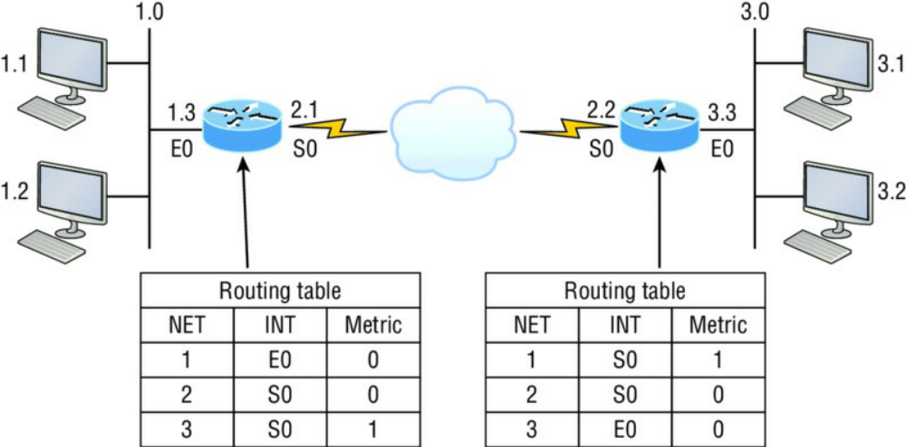
FIGURE 1.14 Routing table used in a router

Network Addresses Protocol-specific network addresses. A router must maintain a routing table for individual routing protocols because each routed protocol keeps track of a network with a different addressing scheme. For example, the routing tables for IP and IPv6 are completely different, so the router keeps a table for each one. Think of it as a street sign in each of the different languages spoken by the American, Spanish, and French people living on a street; the street sign would read Cat/Gato/Chat.

Interface The exit interface a packet will take when destined for a specific network.
Metric The distance to the remote network. Different routing protocols use different ways of computing this distance. I’m going to cover routing protocols thoroughly in Chapter 9, “IP Routing.” For now, know that some routing protocols like the Routing Information Protocol, or RIP, use hop count, which refers to the number of routers a packet passes through en route to a remote network. Others use bandwidth, delay of the line, or even tick count (1/18 of a second) to determine the best path for data to get to a given destination.

And as I mentioned earlier, routers break up broadcast domains, which means that by default, broadcasts aren’t forwarded through a router. Do you remember why this is a good thing? Routers also break up collision domains, but you can also do that using layer 2 (Data Link layer) switches. Because each interface in a router represents a separate network, it must be assigned unique network identification numbers, and each host on the network connected to that router must use the same network number. Figure 1.15 shows how a router works in an internetwork.

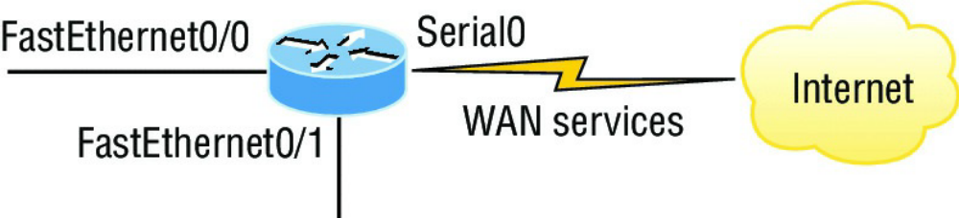
FIGURE 1.15 A router in an internetwork. Each router LAN interface is a broadcast domain.
Routers break up broadcast domains by default and provide WAN services.

Here are some router characteristics that you should never forget:
- Routers, by default, will not forward any broadcast or multicast packets.
- Routers use the logical address in a Network layer header to determine the next-hop router to forward the packet to.
- Routers can use access lists, created by an administrator, to control security based on the types of packets allowed to enter or exit an interface.
- Routers can provide layer 2 bridging functions if needed and can simultaneously route through the same interface.
- Layer 3 devices—in this case, routers—provide connections between virtual LANs (VLANs).
- Routers can provide quality of service (QoS) for specific types of network traffic.

The Data Link Layer
The Data Link layer provides for the physical transmission of data and handles error notification, network topology, and flow control. This means that the Data Link layer will ensure that messages are delivered to the proper device on a LAN using hardware addresses and will translate messages from the Network layer into bits for the Physical layer to transmit.

The Data Link layer formats the messages, each called a data frame, and adds a customized header containing the hardware destination and source address. This added information forms a sort of capsule that surrounds the original message in much the same way that engines, navigational devices, and other tools were attached to the lunar modules of the Apollo project. These various pieces of equipment were useful only during certain stages of space flight and were stripped off the module and discarded when their designated stage was completed. The process of data traveling through networks is similar.

Figure 1.16 shows the Data Link layer with the Ethernet and IEEE specifications. When you check it out, notice that the IEEE 802.2 standard is used in conjunction with and adds functionality to the other IEEE standards. (You’ll read more about the important IEEE 802 standards used with the Cisco objectives in Chapter 2, “Ethernet Networking and Data Encapsulation.”)

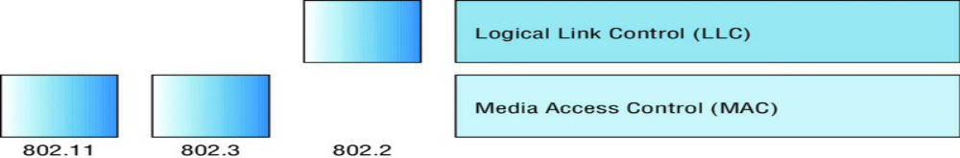
FIGURE 1.16 Data Link layer
It’s important for you to understand that routers, which work at the Network layer, don’t care at all about where a particular host is located. They’re only concerned about where networks are located and the best way to reach them—including remote ones. Routers are totally obsessive when it comes to networks, which in this case is a good thing! It’s the Data Link layer that’s responsible for the actual unique identification of each device that resides on a local network.

For a host to send packets to individual hosts on a local network as well as transmit packets between routers, the Data Link layer uses hardware addressing. Each time a packet is sent between routers, it’s framed with control information at the Data Link layer, but that information is stripped off at the receiving router and only the original packet is left completely intact. This framing of the packet continues for each hop until the packet is finally delivered to the correct receiving host. It’s really important to understand that the packet itself is never altered along the route; it’s only encapsulated with the type of control information required for it to be properly passed on to the different media types.

The IEEE Ethernet Data Link layer has two sublayers:
Media Access Control (MAC) Defines how packets are placed on the media. Contention for media access is “first come/first served” access where everyone shares the same bandwidth—hence the name. Physical addressing is defined here as well as logical topologies. What’s a logical topology? It’s the signal path through a physical topology. Line discipline, error notification (but not correction), the ordered delivery of frames, and optional flow control can also be used at this sublayer.

Logical Link Control (LLC) Responsible for identifying Network layer protocols and then encapsulating them. An LLC header tells the Data Link layer what to do with a packet once a frame is received. It works like this: a host receives a frame and looks in the LLC header to find out where the packet is destined—for instance, the IP protocol at the Network layer. The LLC can also provide flow control and sequencing of control bits.

The switches and bridges I talked about near the beginning of the chapter both work at the Data
Link layer and filter the network using hardware (MAC) addresses. I’ll talk about these next.

NOTE: As data is encoded with control information at each layer of the OSI model, the data is named with something called a protocol data unit (PDU). At the Transport layer, the PDU is called a segment, at the Network layer it’s a packet, at the Data Link a frame, and at the Physical layer it’s called bits. This method of naming the data at each layer is covered thoroughly in Chapter 2.

Switches and Bridges at the Data Link Layer
Layer 2 switching is considered hardware-based bridging because it uses specialized hardware called an application-specific integrated circuit (ASIC). ASICs can run up to high gigabit speeds with very low latency rates.

NB: Latency is the time measured from when a frame enters a port to when it exits a port.

Bridges and switches read each frame as it passes through the network. The layer 2 device then puts the source hardware address in a filter table and keeps track of which port the frame was received on. This information (logged in the bridge’s or switch’s filter table) is what helps the machine determine the location of the specific sending device. Figure 1.17 shows a switch in an internetwork and how John is sending packets to the Internet and Sally doesn’t hear his frames because she is in a different collision domain. The destination frame goes directly to the default gateway router, and Sally doesn’t see John’s traffic, much to her relief.
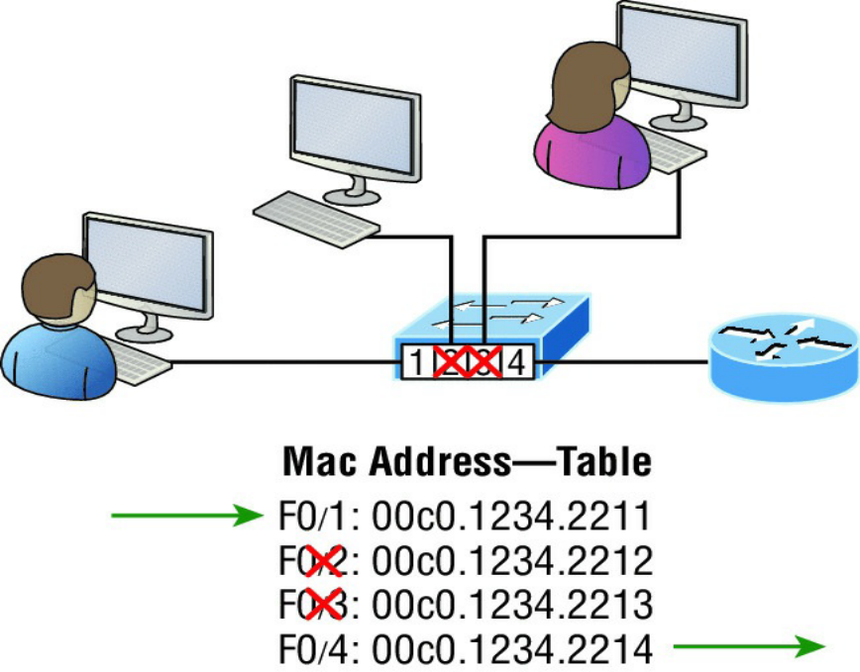
FIGURE 1.17 A switch in an internetwork

The real estate business is all about location, location, location, and it’s the same way for both layer 2 and layer 3 devices. Though both need to be able to negotiate the network, it’s crucial to remember that they’re concerned with very different parts of it. Primarily, layer 3 machines (such as routers) need to locate specific networks, whereas layer 2 machines (switches and bridges) need to eventually locate specific devices. So, networks are to routers as individual devices are to switches and bridges. And routing tables that “map” the internetwork are for routers as filter tables that “map” individual devices are for switches and bridges.

After a filter table is built on the layer 2 device, it will forward frames only to the segment where the destination hardware address is located. If the destination device is on the same segment as the frame, the layer 2 device will block the frame from going to any other segments. If the destination is on a different segment, the frame can be transmitted only to that segment. This is called transparent bridging.

When a switch interface receives a frame with a destination hardware address that isn’t found in the device’s filter table, it will forward the frame to all connected segments. If the unknown device that was sent the “mystery frame” replies to this forwarding action, the switch updates its filter table regarding that device’s location. But in the event the destination address of the transmitting frame is a broadcast address, the switch will forward all broadcasts to every connected segment by default.

All devices that the broadcast is forwarded to are considered to be in the same broadcast domain. This can be a problem because layer 2 devices propagate layer 2 broadcast storms that can seriously choke performance, and the only way to stop a broadcast storm from propagating through an internetwork is with a layer 3 device—a router!

The biggest benefit of using switches instead of hubs in your internetwork is that each switch port is actually its own collision domain. Remember that a hub creates one large collision domain, which is not a good thing! But even armed with a switch, you still don’t get to just break up broadcast domains by default because neither switches nor bridges will do that. They’ll simply forward all broadcasts instead.

Another benefit of LAN switching over hub-centered implementations is that each device on every segment plugged into a switch can transmit simultaneously. Well, at least they can as long as there’s only one host on each port and there isn’t a hub plugged into a switch port! As you might have guessed, this is because hubs allow only one device per network segment to communicate at a time.

The Physical Layer
Finally arriving at the bottom, we find that the Physical layer does two things: it sends bits and receives bits. Bits come only in values of 1 or 0—a Morse code with numerical values. The Physical layer communicates directly with the various types of actual communication media. Different kinds of media represent these bit values in different ways. Some use audio tones, while others employ state transitions—changes in voltage from high to low and low to high. Specific protocols are needed for each type of media to describe the proper bit patterns to be used, how data is encoded into media signals, and the various qualities of the physical media’s attachment interface.

The Physical layer specifies the electrical, mechanical, procedural, and functional requirements for activating, maintaining, and deactivating a physical link between end systems. This layer is also where you identify the interface between the data terminal equipment (DTE) and the data communication equipment (DCE). (Some old phone-company employees still call DCE “data circuit-terminating equipment.”) The DCE is usually located at the service provider, while the DTE is the attached device. The services available to the DTE are most often accessed via a modem or channel service unit/data service unit (CSU/DSU).

Hubs at the Physical Layer
A hub is really a multiple-port repeater. A repeater receives a digital signal, reamplifies or regenerates that signal, then forwards the signal out the other port without looking at any data. A hub does the same thing across all active ports: any digital signal received from a segment on a hub port is regenerated or reamplified and transmitted out all other ports on the hub. This means all devices plugged into a hub are in the same collision domain as well as in the same broadcast domain. Figure 1.18 shows a hub in a network and how when one host transmits, all other hosts must stop and listen.
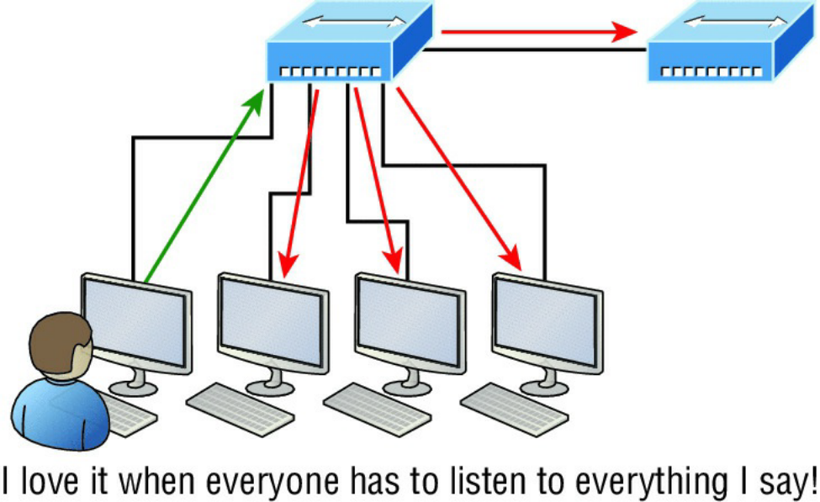
FIGURE 1.18 A hub in a network

Hubs, like repeaters, don’t examine any of the traffic as it enters or before it’s transmitted out to the other parts of the physical media. And every device connected to the hub, or hubs, must listen if a device transmits. A physical star network, where the hub is a central device and cables extend in all directions out from it, is the type of topology a hub creates. Visually, the design really does resemble a star, whereas Ethernet networks run a logical bus topology, meaning that the signal has to run through the network from end to end.

NB: Hubs and repeaters can be used to enlarge the area covered by a single LAN segment, but I really do not recommend going with this configuration! LAN switches are affordable for almost every situation and will make you much happier.
Topologies at the Physical layer
One last thing I want to discuss at the Physical layer is topologies, both physical and logical. Understand that every type of network has both a physical and a logical topology.

- The physical topology of a network refers to the physical layout of the devices, but mostly the cabling and cabling layout.
- The logical topology defines the logical path on which the signal will travel on the physical topology.

Figure 1.19 shows the four types of topologies.

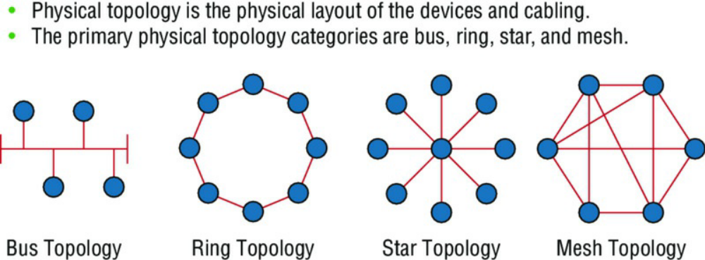
FIGURE 1.19 Physical vs. Logical Topolgies

Here are the topology types, although the most common, and pretty much the only network we use today is a physical star, logical bus technology, which is considered a hybrid topology (think Ethernet):

- Bus: In a bus topology, every workstation is connected to a single cable, meaning every host is directly connected to every other workstation in the network.
- Ring: In a ring topology, computers and other network devices are cabled together in a way that the last device is connected to the first to form a circle or ring.
- Star: The most common physical topology is a star topology, which is your Ethernet switching physical layout. A central cabling device (switch) connects the computers and other network devices together. This category includes star and extended star topologies. Physical connection is commonly made using twisted-pair wiring.
- Mesh: In a mesh topology, every network device is cabled together with connection to each other. Redundant links increase reliability and self-healing. The physical connection is commonly made using fiber or twisted-pair wiring.
- Hybrid: Ethernet uses a physical star layout (cables come from all directions), and the signal travels end-to-end, like a bus route.

Summary
- I started by discussing simple, basic networking and the differences between collision and broadcast domains.

- I then discussed the OSI model—the seven-layer model used to help application developers design applications that can run on any type of system or network. Each layer has its special jobs and select responsibilities within the model to ensure that solid, effective communications do, in fact, occur. I provided you with complete details of each layer and discussed how Cisco views the specifications of the OSI model.

- In addition, each layer in the OSI model specifies different types of devices, and I described the different devices used at each layer.

- Remember that hubs are Physical layer devices and repeat the digital signal to all segments except the one from which it was received. Switches segment the network using hardware addresses and break up collision domains. Routers break up broadcast domains as well as collision domains and use logical addressing to send packets through an internetwork.

